***Project Title:  
Online Airline Booking System***

**Course Project Advisor:**

**Prof O. Kalu**

**Team members:** *Student Names and IDs*

* **Robel Tesfamariam -109706**
* **Ekubay Berihane-109542**
* **Haftu Reda-987023**
* **Amanuel Tekelemariam – 982578**

**Saturday, June 22, 2019**

**MUM**

**Table of Contents**

**1. Vision Document** 1

1.1 Introduction 1

1.2. Positioning Problem Statement 1

1.3 Stakeholder Description 2

1.4. Tools and technology 2

1.5 Scope of the project 3

**2. Software Requirement Analysis** 4

2.1 Keyword Abstraction 4

2.2 Use case diagram 5

2.3 Use case description 6

**2.** **System Architecture Analysis and design** 9

**3.** **Use case Analysis and design** 10

3.1 Class Diagram 11

3.2 Sequence diagram 12

3.3 Collaboration and VOPC diagrams 13

4. **Wireframe**: Mocking User Interface 18

5. Implementation 21

5.1 Mapping class diagram to Entity relationship 21

5.2 A working sources code**:** User manual 22

5.2.1 Creating database and Entities 22

5.2.2 Running admin and customer related functionalities 22

# **1. Vision Document**

## 1.1 Introduction

Airline reservation system (ARS) is an automated reservation system is used for reservations of a particular airline with a [global distribution system](https://en.wikipedia.org/wiki/Global_distribution_system) (GDS). This supports travel agencies and other distribution channels in making reservations for airlines in a single system. Airline reservation systems incorporate the following services: airline schedules, fare tariffs, passenger reservations and ticket records. An airline's direct distribution works within their own reservation system, as well as pushing out information to the global distributed system (GDS). Since airline reservation systems are business critical applications, and they are functionally quite complex, the operation of an in-house airline reservation system is relatively expensive.

We planned to develop an online air-ticket reservation system which we call it here as OneClickTicket**.** The intended project outcome is to solve the booking problem and enable customers to manage their flight from home by a button click. We also want to introduce rewards for customers who are frequently traveling via a airline. The airline wants to differentiate its customers as new customers and existing customers. That means it wants to store the customers information when they book a flight. When the customer’s returns back their information will be retrieved from the airlines database.

## 1.2. Positioning Problem Statement

The problem of having a outdated booking system for airline ticket affects customers, staff, and the company itself. The impact of which is Customers are placed on hold for longer time, seat management becomes very difficult, and flights can be delayed and cancelled because of some external and internal factors. A successful solution will be to introduce the **OneClickTicket** online flight management system that enable customers to manage their flight by using any computer or smartphones from home. This website provides the customer and staffs an easy interface to manage and schedule their flights. For All local and international travelers provides the most memorable, easy to book interface 24 hour a day and 7 days a week. To this end, we want to develop a web based application which enable passengers, agents and system administrator of the airline to perform the following services:

1. **Scheduling a monthly flights plan**- this is one of the core functionalities which is performed at flight admission office. The main task here is to optimally schedule list of flights (destinations and departures) along with available plans and/or pilots.
2. **Flight reservation details:** It includes the originating flight terminal and destination terminal, along with the stops in between, the number of seats booked/available seats between two destinations etc. Users access an airline’s inventory through an availability display. It contains all offered flights for a particular city-pair with their available seats in the different booking classes**. T**his typically includes
3. **Customer details:** It records customer code, name, address and phone number. This information may be used for keeping the records of the customer for any emergency or for any other kind of information. Specifically, reservations for individual passengers or groups are stored in a so-called [passenger name record](https://en.wikipedia.org/wiki/Passenger_name_record) (PNR).
4. **Revenue reporting:** Once a flight has departed, the reservation system is updated with a list of the checked-in passengers (e.g. passengers who had a reservation but did not check in (no shows) and passengers who checked-in but did not have a reservation (go shows). Finally, data needed for revenue accounting and reports are generated by administrative systems.

## 1.3 Stakeholder Description

|  |  |  |
| --- | --- | --- |
| **Name** | **Description** | **Responsibilities** |
| Admin/Agents | Schedule flight, cancel or update flight status, notify customer etc | Admins or Agents are responsible for managing the flight, schedule and reschedule process. |
| Staffs | Assist customer, load unload baggage, check-in customer and baggage, provide wheelchair, managing ticketing | Staffs manage helping customers during checking, boarding, providing information for travelers, cleaning the plane, greeting customers, and flying the plane. |
| Customers | Customers can check ticket availability, flight schedule, flight status, pricing, special discount | Customers are responsible for booking a flight, checking on time, checking their belongings |
| Developers | Developers develop the website based on the airlines requirement. | Developers are responsible for maintaining the website, fixing bugs, adding new features, and improving the system based on users need |
| Testers | Testers test the website (System) using some testing tools such as JUnit | Testers are responsible for testing the website or system (Integration testing) |

## 1.4. Tools and technology

**UI (Frontend Technology):** We will use Thymeleaf Template Engine which is suited for serving HTML5 at the view layer of MVC-based. We prefer it to other technologies due to time constraint to understand and use other (such as angular) UI design tool.

**i. Server Side Technology:** We selected spring boot is due to the following advantageous features:

* Spring MVC is a complete HTTP oriented MVC framework managed by the Spring Framework.
* Spring integrates a wide range of different modules such as, as *spring-core*, *spring-data*, *spring-web*. With this tool we can tell spring how many of them to use and we will get a fast setup for them. So, Spring MVC is a framework to be used in web applications.
* Good Integration with other frameworks such as Hibernate
* Comes with Default Spring Starters, which come with some default spring configuration dependency (like Spring Core, Web-MVC, Tomcat, Validation, Data Binding, and Logging).

1. **Database Technology:** Since our system is small and we do not need to store lots of data, MySQL is sufficient to store data in for our specific application. Besides, our system do not need a distributed architecture to store data as the scope of this project is limited to work in a single workstation.

## 1.5 Scope of the project

This project is a prototype for the flight management system and it is restricted within only the booking subsystem of the airline business process. This project is useful for the flight management team and as well as to the passengers. The purpose of the online flight management system is to ease flight management and to create a convenient and easy-to-use application for passengers, trying to buy airline tickets. The system is based on a relational database with its flight management and reservation functions. We will have a database server supporting major cities airport as well as number of flights by Airline Company.

# **2. Software Requirement Analysis**

## 2.1 Keyword Abstraction

In order to get a high-level understanding of the problem domain, we used a word cloud or weighted list of words. This visual design is a novelty visual representation of text data, typically used to depict keyword metadata (keyword abstraction) on websites, or to visualize free form text. The keyword abstraction are usually single words, and the importance of each keyword abstraction is shown with font size or color as follows.

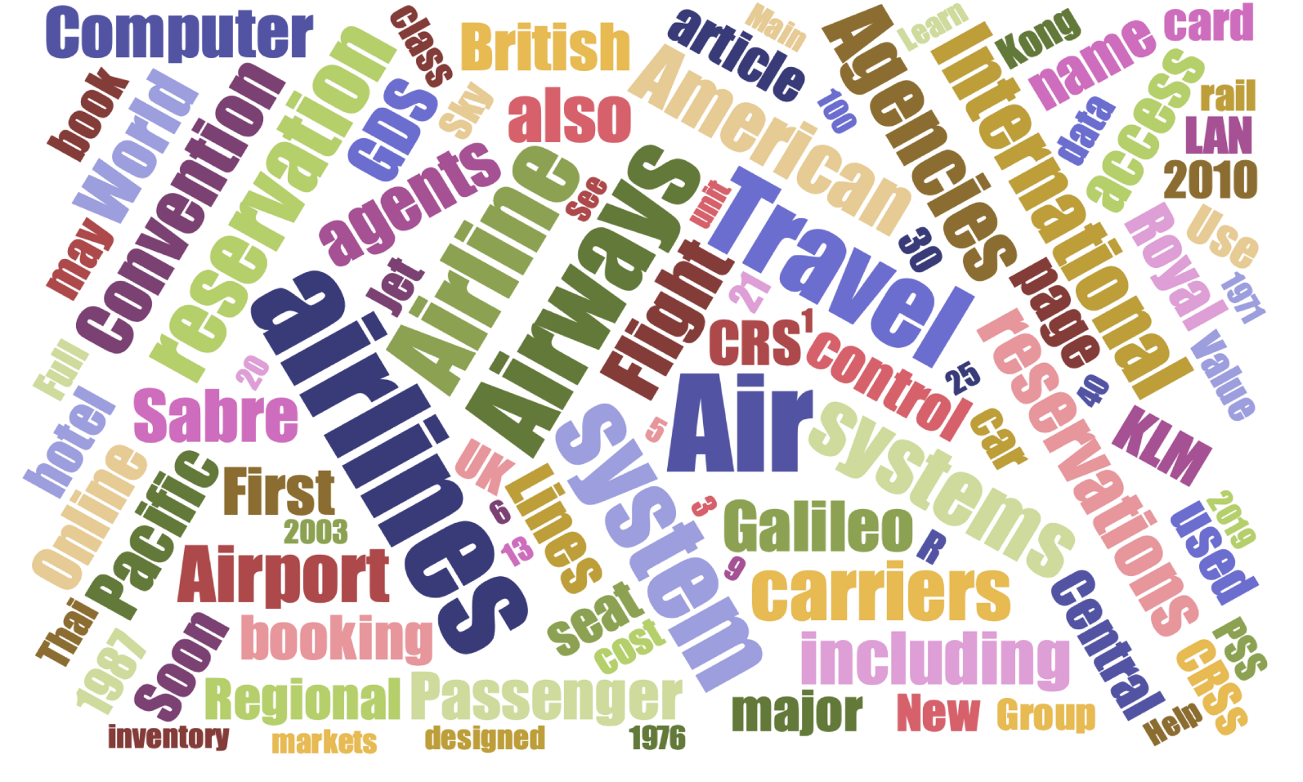

## 2.2 Use case diagram



System



Admin



Passenger

## 2.3 Use case description

|  |  |  |
| --- | --- | --- |
| **Use case Number** | #1 | |
| **Use case Name:** | RegisterListOfAirports | |
| **Description:** | This use case us mainly focusing on records list of airports and associated information | |
| **Involved actors:** | Employees, or agents | |
| **Precondition:** | There exist list of predefined airports to be used in the XYZ airline identified as a business areas, the user know(opens) the URL of the this application | |
| **Flow of event** | ***user*** | ***System*** |
| 1. Employees/Agent clicks a Button for registering list of airports the web | 2 the System displays a form to record one airport information at a time.(A1) |
| 3.The user fills a form and submit the form | 4. The system validate the form and save it into the database. (A1) |
| **Post condition** |  | |
| **Alternatives** | A1: If the user missed required information, the system notifies the user to provide the correct information | |
| **Business logic** | The system records only list of identified business areas (flight routs) that are endorsed by the company | |

|  |  |  |
| --- | --- | --- |
| **Use case Number** | #2 | |
| **Use case Name:** | Scheduling (planning)a monthly flight rout | |
| **Description:** | This use case is used to records list of planned flight routs | |
| **Involved actors:** | Employees, or agents | |
| **Precondition:** | The user knows(opens) the URL of this application | |
| **Flow of events** | ***user*** | ***System*** |
| 1. Employees/Agent clicks a **scheduling Button** (Menus)for registering list of planed flight routs | 2 the System displays a form to record planned flights information |
| 3.The user fills a form for each flight routs at a time and submit the form | 4. The system validate the form and save into the database (A1) |
| **Post condition** | * The system displays a confirmation message. * The user either may continue the above steps to further record other planned schedule he/she may exit the system | |
| **Alternatives** | A1: If the user missed required information, the system notifies the user to provide the correct information | |
| **Business logic** | The system records only list of identified business areas (flight routs) that are endorsed by the company | |

|  |  |  |
| --- | --- | --- |
| **Use case Number** | #3 | |
| **Use case Name:** | FlightReservation (BookingService) | |
| **Description:** | This use case is used to record each flight reservation (Booking) information for each passenger | |
| **Involved actors:** | Passenger or agents | |
| **Precondition:** | Employees/Agent knows(opens) the URL of this application | |
| **Flow of event** | ***user*** | ***System*** |
| 1. Passenger /Agent clicks a reservation button(menu) for booking his/her flight routs | 2 the System displays a form to record planned flights information |
| 3.The user fills a form for each flight routs at a time and submit the form | 4. The system validate the form (A1) and displays list of possible flight rout |
|  | 5 The user select one of the available flight root | The system save user preference (A1) and asks user for database and the system ask user for payment option |
|  |  |  |
|  | 5. The Passenger /Agent fills appropriate payment option and information | 6. The system validates the filled payment option (A2). If everything is correct, the system saves this into the database |
| **Post condition** | The system displays a confirmation message. The system also sends confirmation message and a detailed flight information via email. | |
| **Alternatives** | A1: If the user missed required information, the system notifies the user to provide the correct information  **A2:** The system displays payment related notification message | |
| **Business logic** | The system records only list of identified business areas (flight routs) that are endorsed by the company | |

|  |  |  |
| --- | --- | --- |
| **Use case Number** | #4 | |
| **Use case Name:** | Checking-in | |
| **Description:** | This use case allows passengers to check-in his/her flight online | |
| **Involved actors:** | Passenger | |
| **Precondition:** | Passenger knows(opens) the URL of this application | |
| **Flow of event** | ***User*** | ***System*** |
| **1.** passengers clicks a check-in button(menu) he/she is prepared to travel | **2** the System displays a check-in form in fill in the flight numbers and ticket number or |
| **3**.The Passenger fills the check-in form and clicks a submit button | **4.** The system validate the form and save into the database (A1) and sends checked-in confirmation |
| **Post-condition** | The system displays a confirmation message. The system also sends confirmation message and a detailed flight information via email. | |
| **Alternatives** | A1: If the user missed required information, the system notifies the user to provide the correct information | |
| **Business logic** | The system records only list of identified business areas (flight routs) that are endorsed by the company | |

|  |  |  |
| --- | --- | --- |
| **Use case Number** | #5 | |
| **Use case Name:** | Checking-in | |
| **Description:** | This use case allows passengers to check-in his/her flight online | |
| **Involved actors:** | Passenger | |
| **Precondition:** | Passenger knows(opens) the URL of this application | |
| **Flow of event** | ***User*** | ***System*** |
| **1.** passengers clicks a check-in button(menu) he/she is prepared to travel | **2** the System displays a check-in form in fill in the flight numbers and ticket number or |
| **3**.The Passenger fills the check-in form and clicks a submit button | **4.** The system validate the form and save into the database (A1) and sends checked-in confirmation |
| **Post-condition** | The system displays a confirmation message. The system also sends confirmation message and a detailed flight information via email. | |
| **Alternatives** | A1: If the user missed required information, the system notifies the user to provide the correct information | |
| **Business logic** | The system records only list of identified business areas (flight routs) that are endorsed by the company | |

# **System Architecture Analysis and design**

Spring Web Model-View-Controller architecture: The project architecture adapts a Spring MVC Java framework to build web applications. This framework Model-View-Controller design pattern that provides an elegant solution to use MVC in spring framework by the help of Dispatcher Servlet. Here, Dispatcher Servlet is a class that receives the incoming request and maps it to the right resource. To this end, the overall Spring MVC Software Architecture includes three main components (Presentation layer, business layer and data layer). Each of these layers in turn contains other subcomponents such as controllers, models, and views (See the figure below)

* **View** - A view represents the user interface that the provides information in a particular format such as Thymeleaf or JSP page.
* **Controller** - This is a class which is used as DispatcherServlet that works as the front controller. It is responsible to manage the flow of the Spring MVC application. A controller contains the business logic of an application. It also holds the presentation (UI) logic which make it responsible for process user request (GET / POST), prepare data for the view and render the view.
* **Services** classes hold the business logic which in turn call repository method to render user requests.
* **Model** - A model contains the data of the application. A data can be a single object or a collection of objects. Models (entity classes) holds the about the application data.
* **DAO (Repositories)** class implement the database CRUD operations (create / read / edit / delete) in the database for certain entity class (model).



# **Use case Analysis and design**

Use case analysis is a technique used to identify the requirements of a system and the information used to both define processes used and classes. This in turn will be used both in the use case diagram and the overall use case in the development or redesign of a software system. The use case analysis is the foundation upon which the system will be built. To this end, class diagram, Sequent diagram and Coloration diagram are presented in the following section

## 3.1 Class Diagram

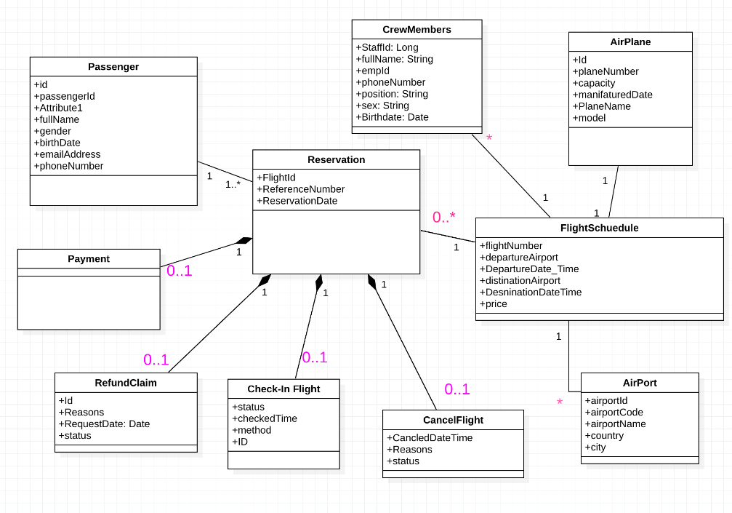

## 3.2 Sequence diagram



Passenger

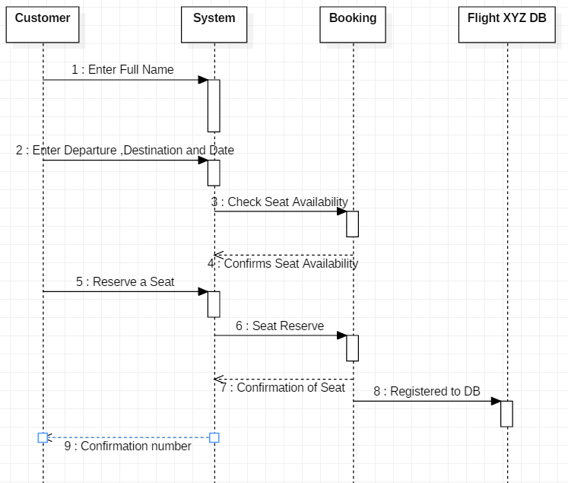





Passenger

## 3.3 Collaboration and VOPC diagrams

# 

**COLLABORATION DIAGRAM FOR ONECLICK FLIGHT BOOKING SYSTEM**

COLLABORATION DIAGRAM FOR USER REGISTRATION

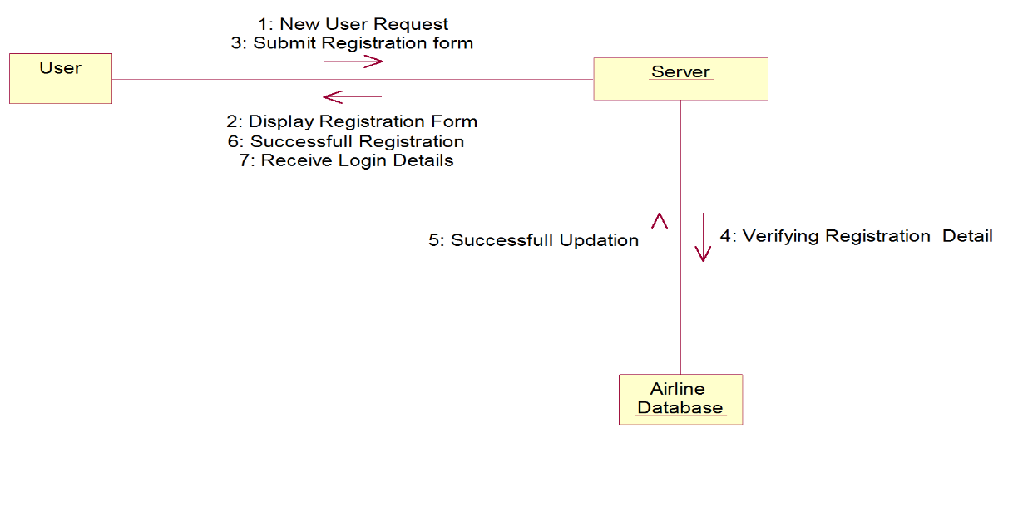

i. COLLABORATION DIAGRAM FOR MEMBER LOGIN

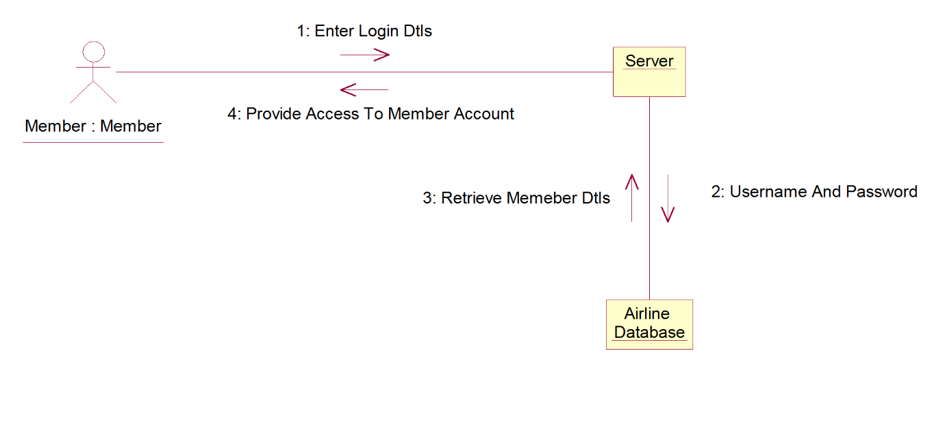

ii. COLLABORATION DIAGRAM FOR FLIGHT BOOKING

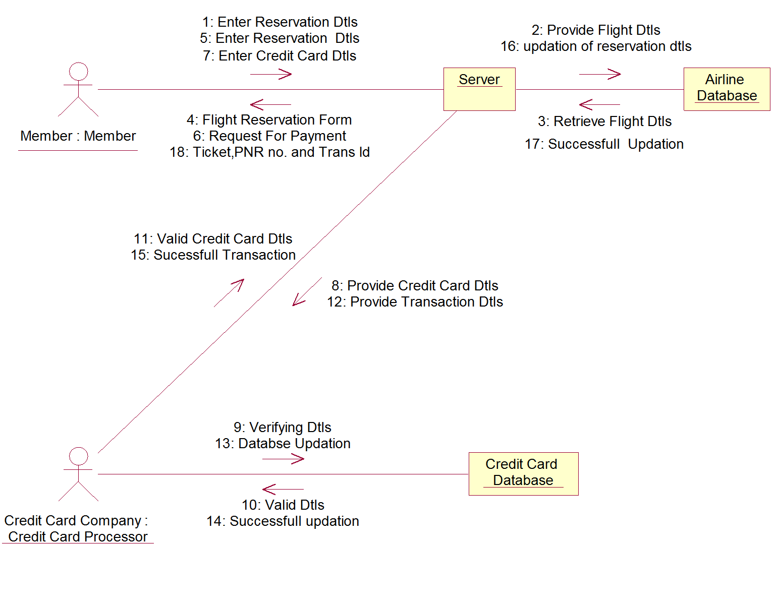

1. COLLABORATION DIAGRAM FOR FLIGHT CANCELATION

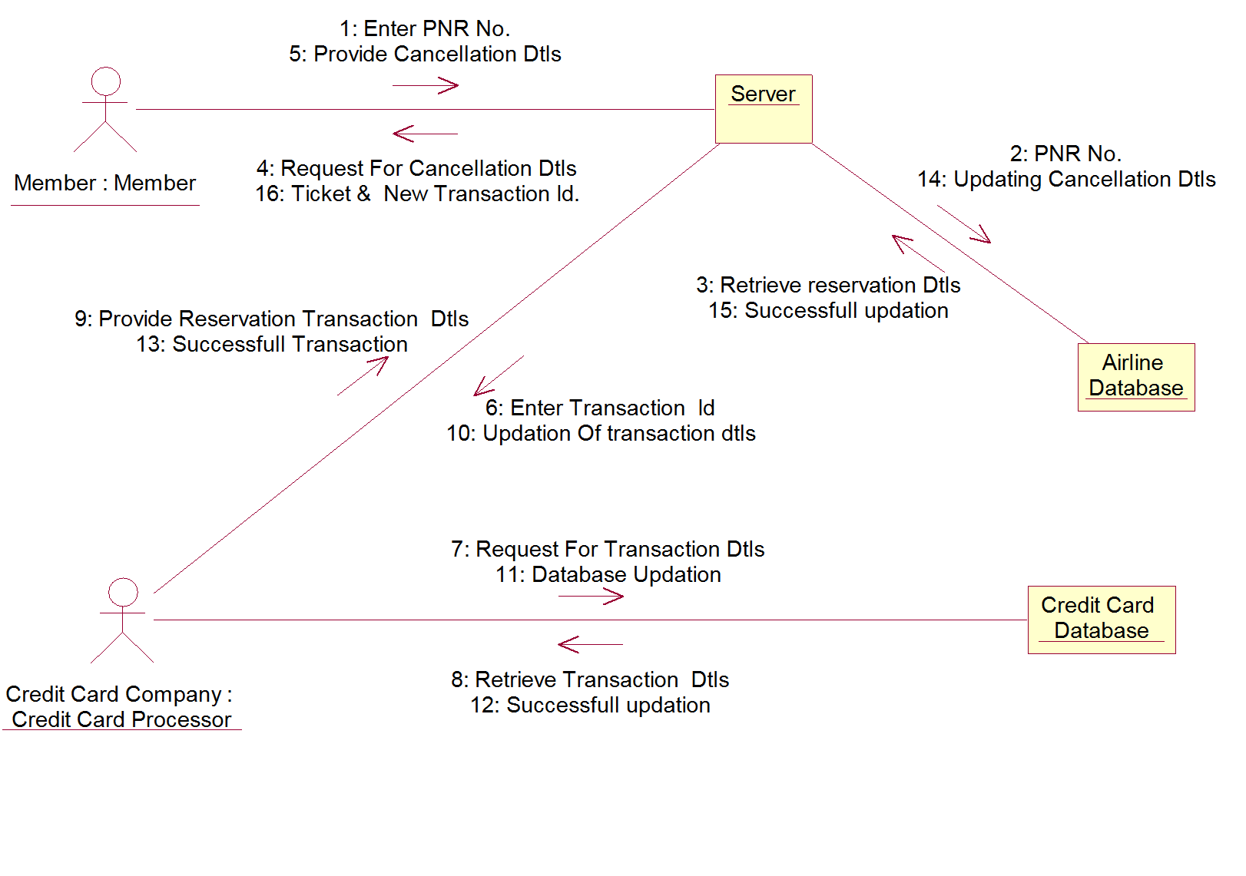

**VOPC DIAGRAM FOR ONECLICK FLIGHT BOOKING SYSTEM**

VOPC DIAGRAM FOR LOGIN SYSTEM



VOPC DIAGRAM FOR SEARCHING FLIGHTS



VOPC DIAGRAM FOR SELECTING FLIGHTS



VOPC DIAGRAM FOR BOOKING FLIGHTS



VOPC DIAGRAM FOR CANCELING FLIGHTS



1. **Wireframe**: Mocking User Interface

A **mockup or wireframe** is a static high-profile visual design draft of a design or device, used to represent the structure of information, visualize the content and demonstrate the basic functionalities in a static way. The following list of figures represent the structure of functionality which in turn is organized using subsystem decomposition

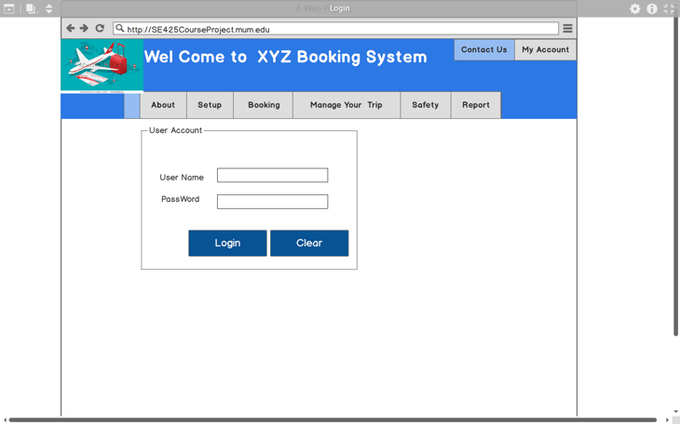

**Mocking Login UI**

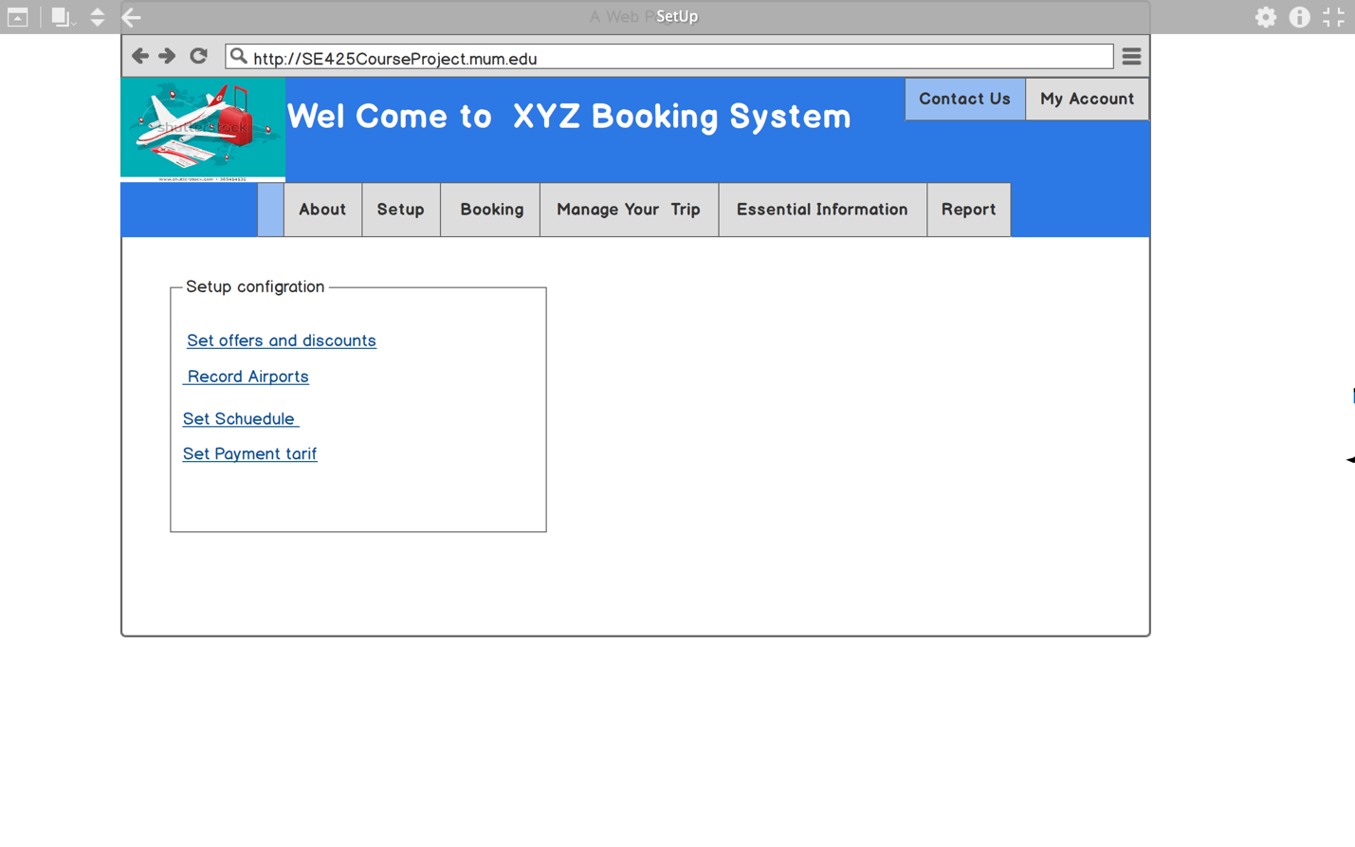

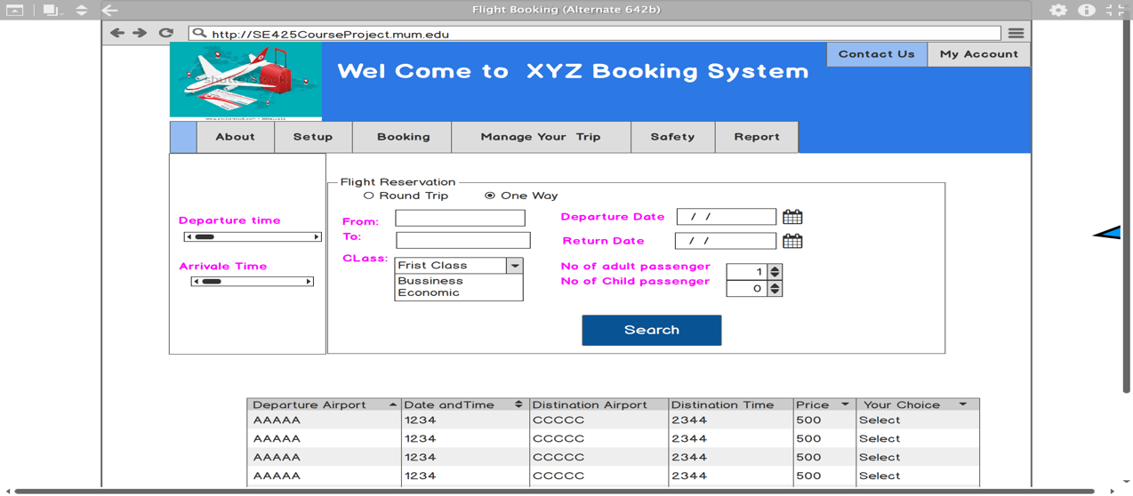

Mocking flight scheduling functionality

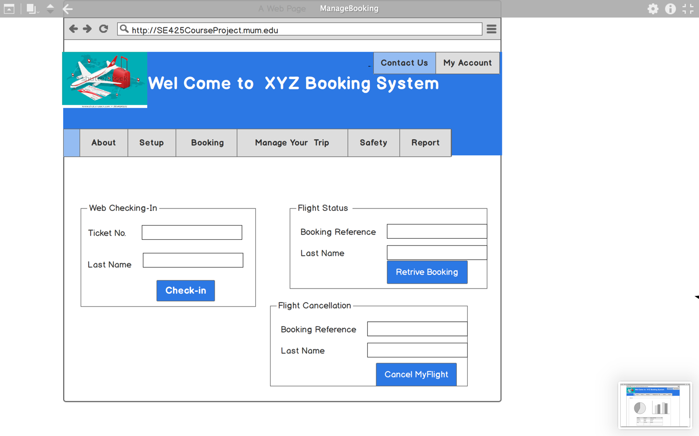

Mocking three functionality: Checking-in, flight cancelation and refunding UI

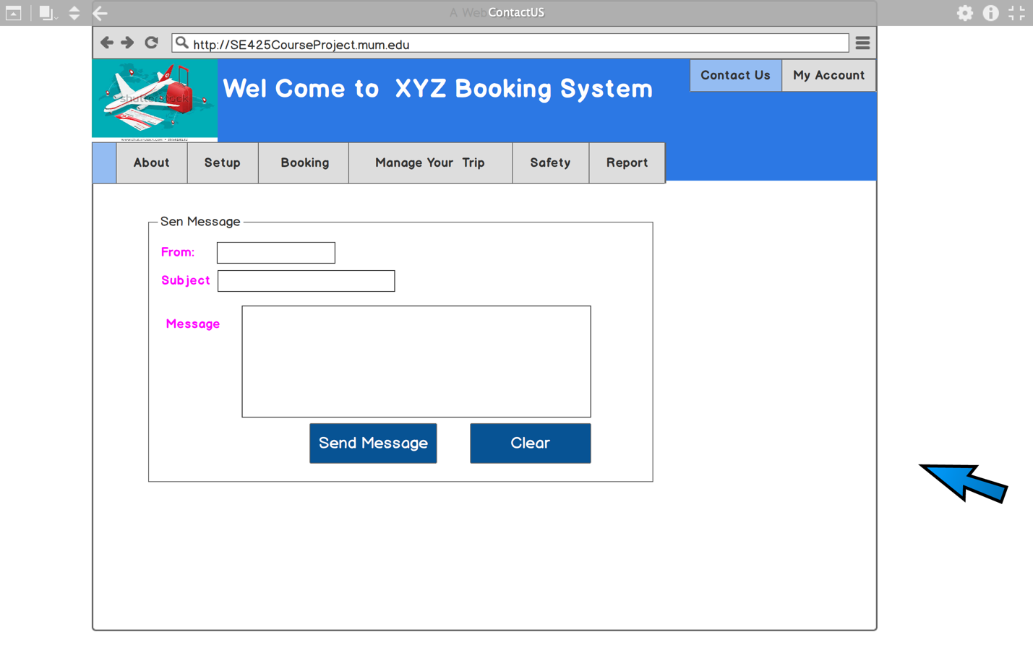

Mocking messaging UI

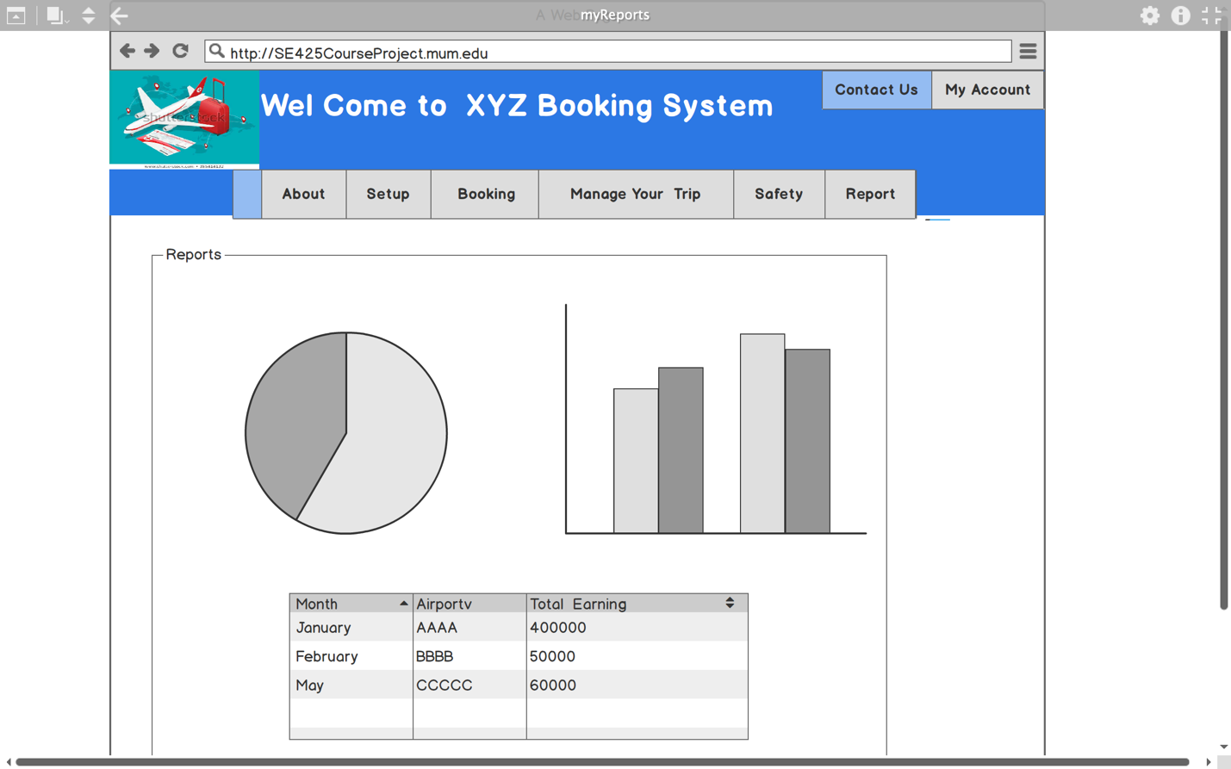

Mocking report generating subsystem UI

1. **Implementation**

5.1 Mapping class diagram to Entity relationship

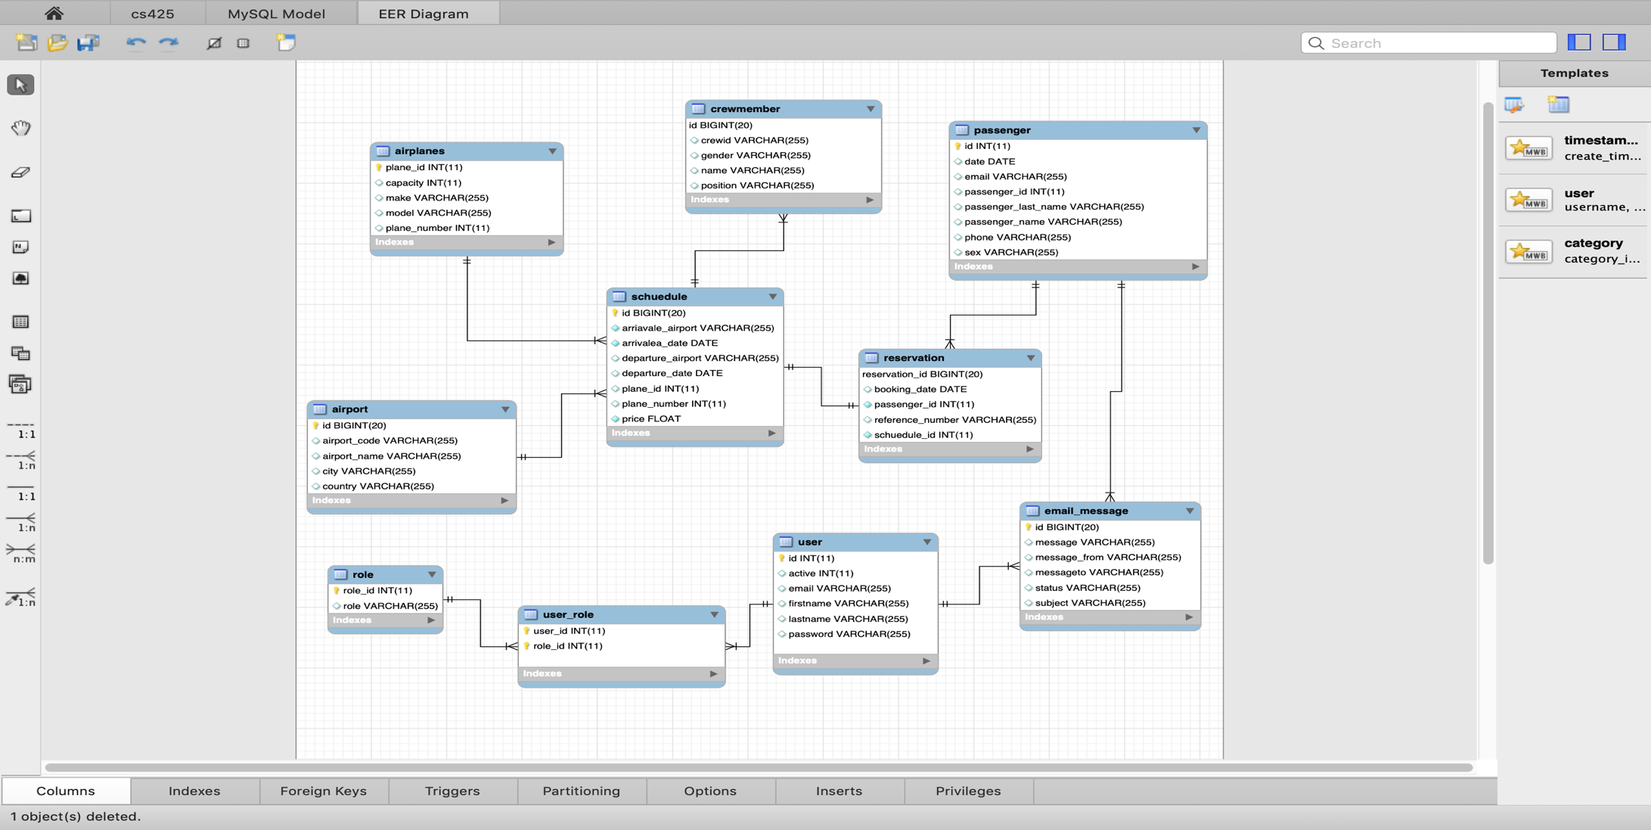

5.2 A working sources code**:** User manual

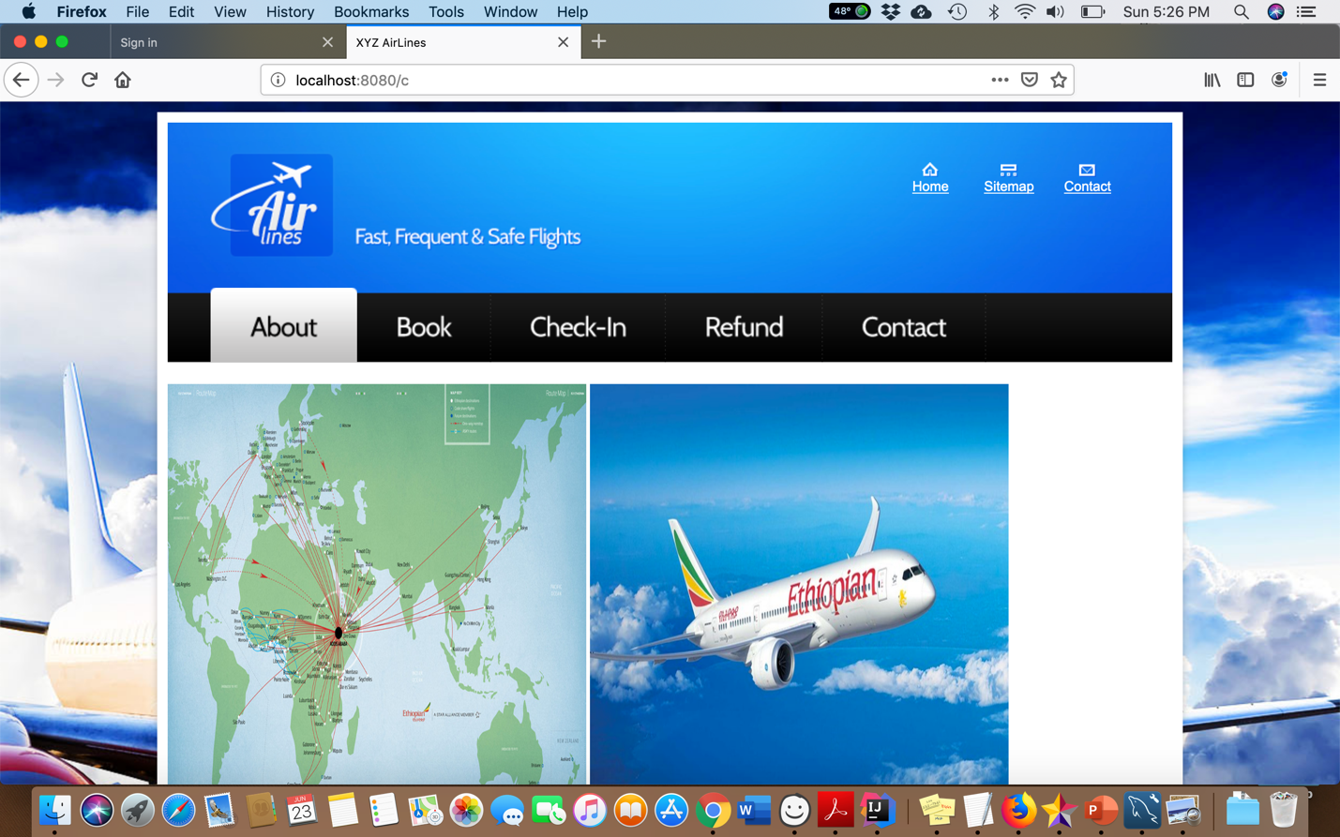

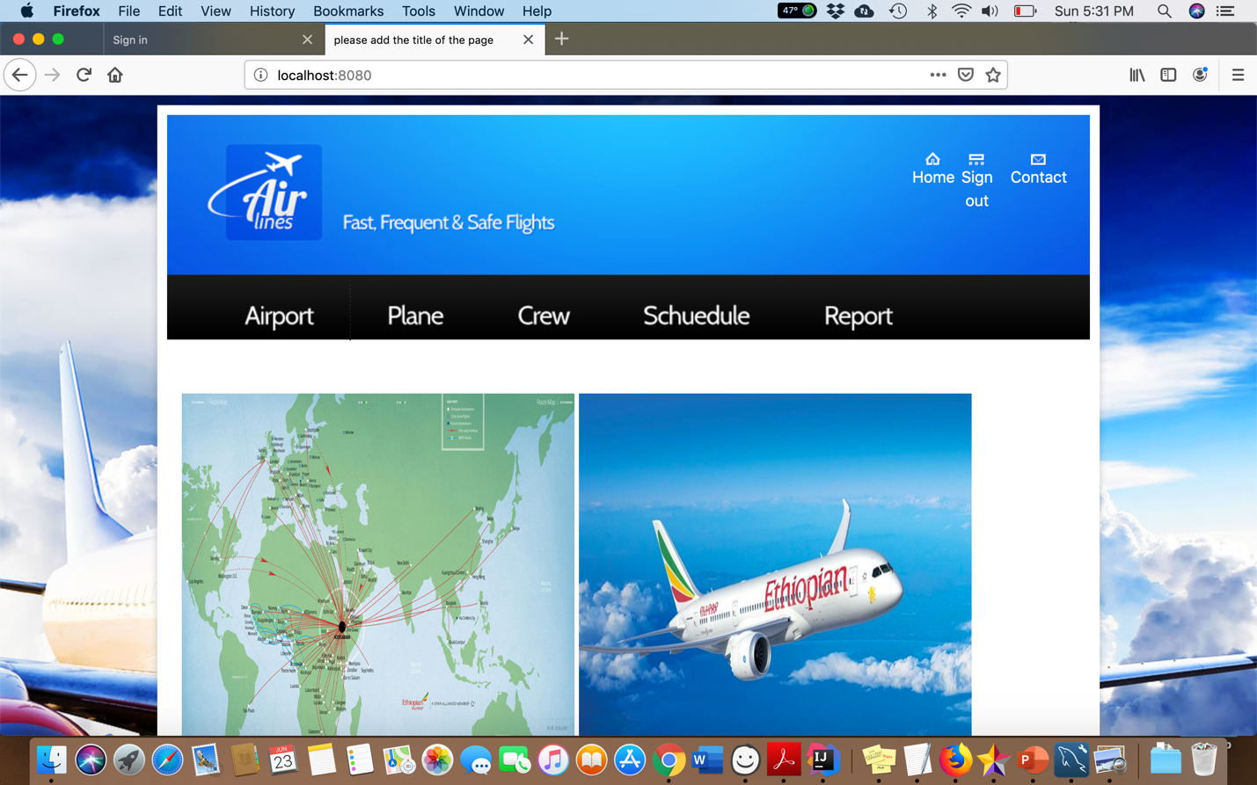

5.2.1 Creating database and Entities

Follow the steps in the “Readme.doc” file included in the project deliverables.

5.2.2 Running admin and customer related functionalities

Follow the steps in the “Readme.doc” file included in the project deliverables.